BROTHER’S KEEPERS 34  PRESENTS  Rumble in the Park  Dice Roll  August 20th,2022  The 6th Annual fundraising event benefiting the kids of Sevier County. Hosted by the DeQueen Chapter of the Brother’s Keepers Motorcycle Club. Come out and help us help the kids of Sevier County. If you don’t ride a motorcycle that’s okay automobiles are welcomed. Come out to the DeQueen Herman Dierks City Park Pavilion and join the fun.  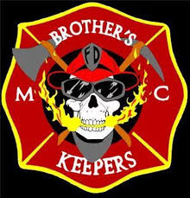  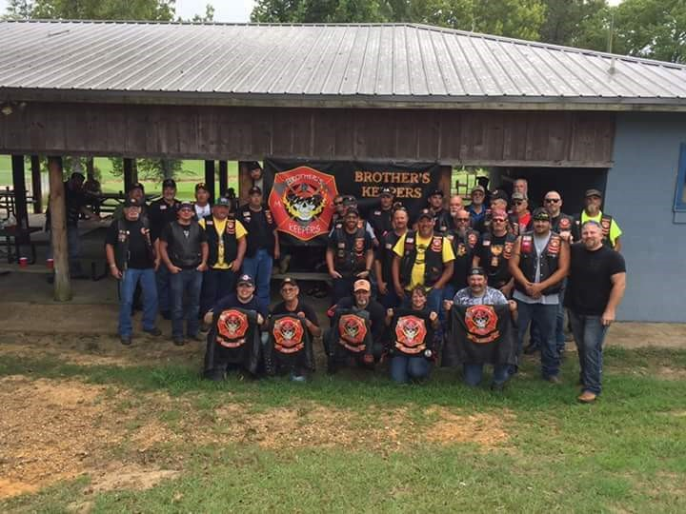 | Live Auction  ────  DeQueen Herman Dierks community  Building  ────  Fun For All  ────  Register – 8:00am till 9:00am  ────  $20.00 a person  Includes dice run sheet  Brother’s Keeper  #34  DeQueen AR  Jerry Ligon - President  870-784-6283  Tim Litchford – VP  870-584-8835  August 21st 2021  8:00am - ?
